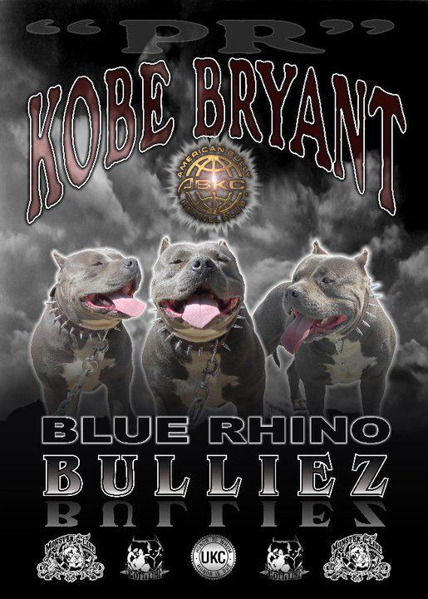
Central Coast Bullies is an up and coming, family run, American Bully Kennel. CCB is located on the beautiful Central Coast of California. Our foundation blood is made up of Gottyline, Razors Edge, Monster G, and Mikelands. We strive to produce head turning American Bullies. We breed for blocky heads, thick bones, conformation, and most importantly, temperament. Our dogs are family dogs, never used for fighting. They are well socialized in the community, spending weekends at the wharf or the beach. We have raised all of our dogs with our own children. We breed for the best. A CCB dog will not disappoint. We will have a limited number of select breedings each year. All dogs will be ABKC or UKC registered. Please feel free to check our site frequently for new additions and planned breedings. If you have any questions about a CCB dog or the American Bully breed in general, don’t hesitate to ask.

